**ASSIGNMENT 2 (ASDM)**

1. **Creating component**

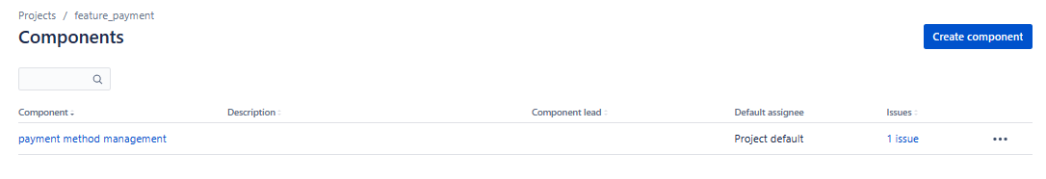

1. **Creating version with release date**

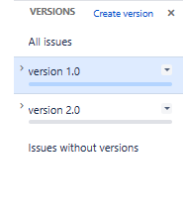

1. **Create sprint backlog, start sprint, end sprint**

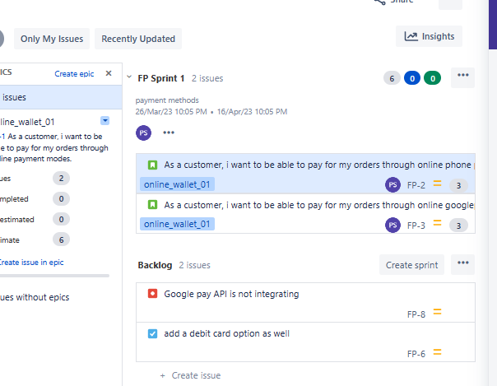

1. **Active sprint**

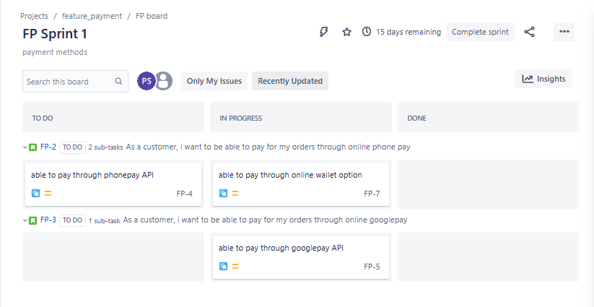

1. **Burnup chart**

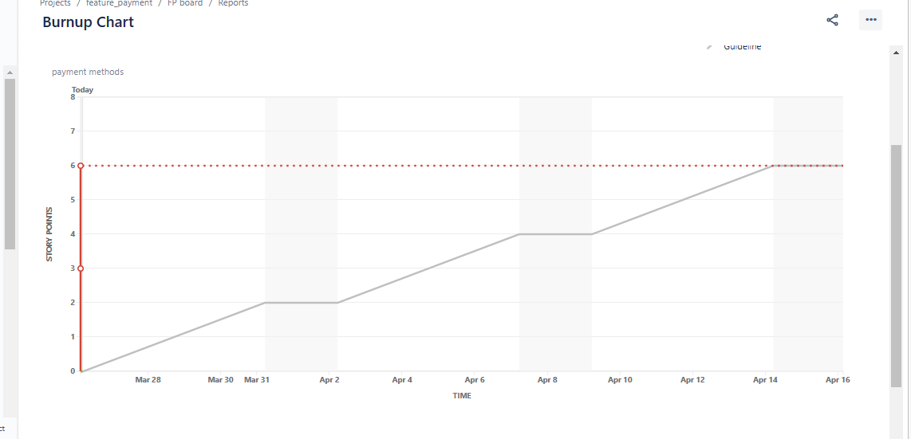

1. **Burn down chart**

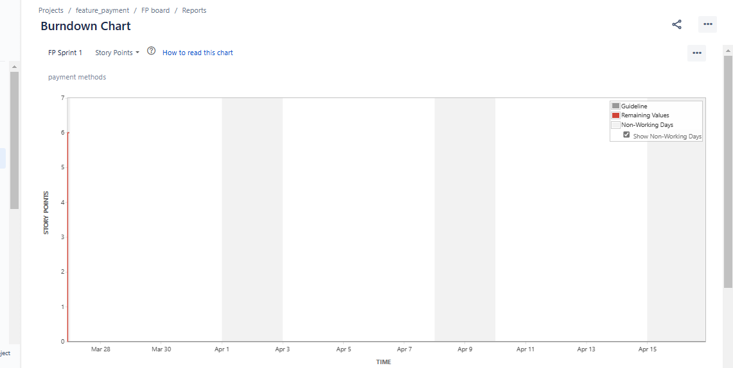

1. **Sprint report**

